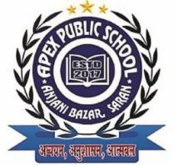 APEX PUBLIC SCHOOL (ANJANI BAZAR)
Time:3hrs. 2nd TERMINAL EXAMINATION (NOV - 2025) DATE:-03/12/2025
CLASS – 1st SUB – G.K FULL MARKS-40

A. Rearrange the letters to find the names of materials. (5 Marks)
- ODWO – ________
- MEALT – ________
- GSLAS – _______
- CYLA – ________
- TONCOT – ________

B. Write the name of the country where they are situated. (5 Marks)
- Opera House – ________
- Angkor Wat – ________
- Pyramid of Giza – ________
- Great Wall of China – ________
- The Potala Palace – ________

C. Write the name of the capital city of the country. (5 Marks)
- England – ________
- China – ________
- France – ________
- Japan – ________
- Bangladesh – ________

Write the names of all the planets in our solar system in Hindi.

(10 Marks)

E. Write the name of the city where they are situated. (5 Marks)
- Vaishno Devi – _______
- Golden Temple – _______
- Dilwara Temple – ________
- Sun Temple – ________
- Mahabodhi Temple – ________

F. Write the names of the landforms. (10 Marks)
- A dry land where sand is all around. ________
- A piece of land surrounded by water on all sides. ________
- A land between two mountains. ________
- A large area filled with trees. Many animals and birds live here. ________
- A High land whose top is called a Peak.___________.

